Page 6 Account Details Screen – Navigate stage, check in solution

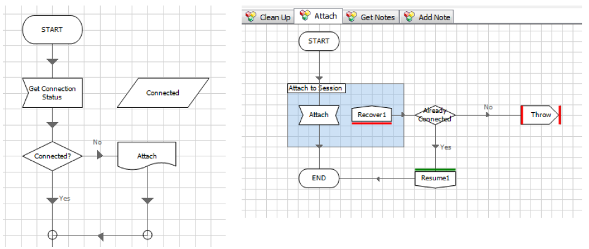

* Wait stage at the start of each Action

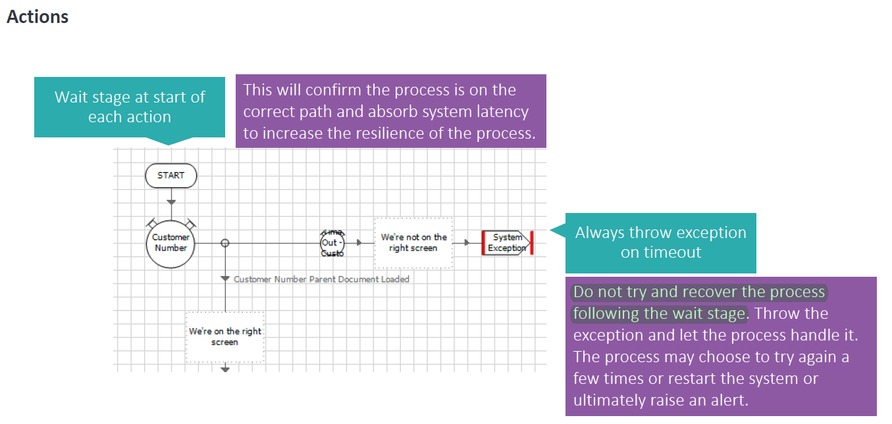

* Do not call published actions from within an object. Let it be done by process.

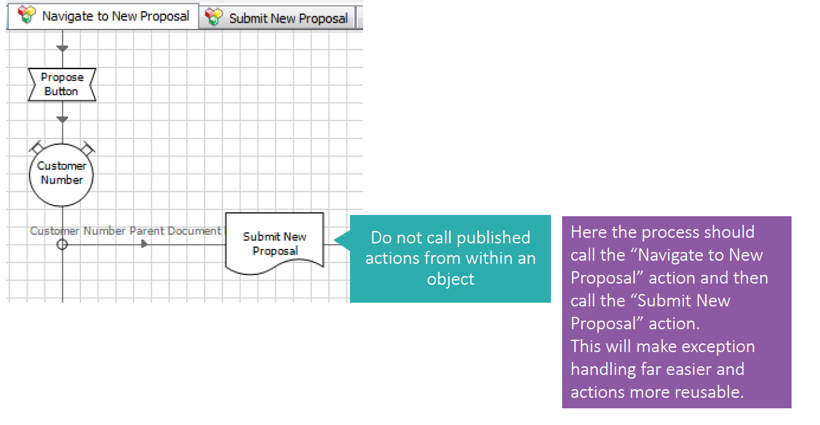

* In the below case the Decision Stage should be in process and ‘Set Account Limit’ should be a separate action in the object which is called from process stage based on the decision. Remember – Getter Setter

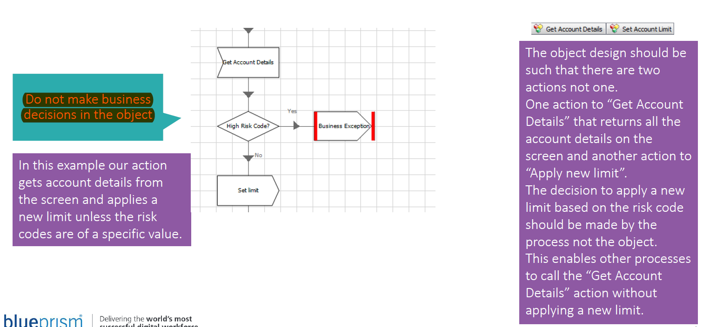

* Provide Exception Type and specific Exception Details for all Exceptions

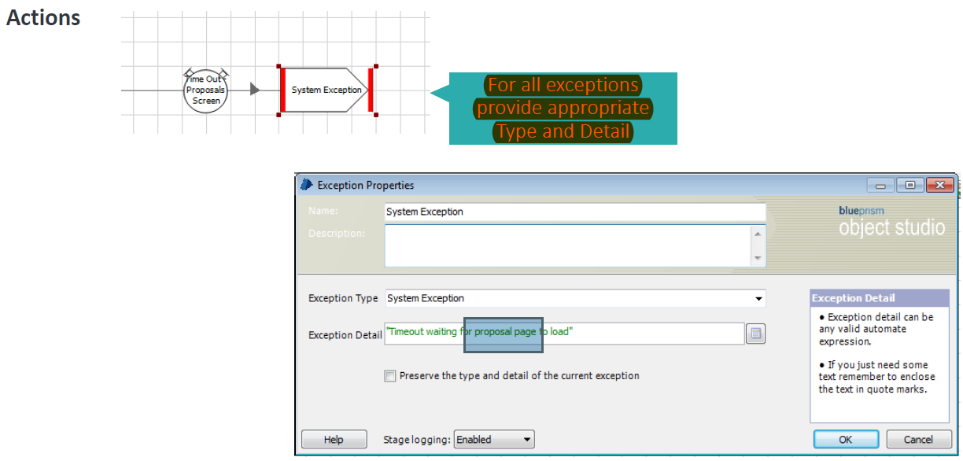

Provide Description to

1) Inputs (Start Stage)

2) Outputs (End Stage)

3) Actions (Right Click on the block – Named, Description, Precondition, Post Condition)

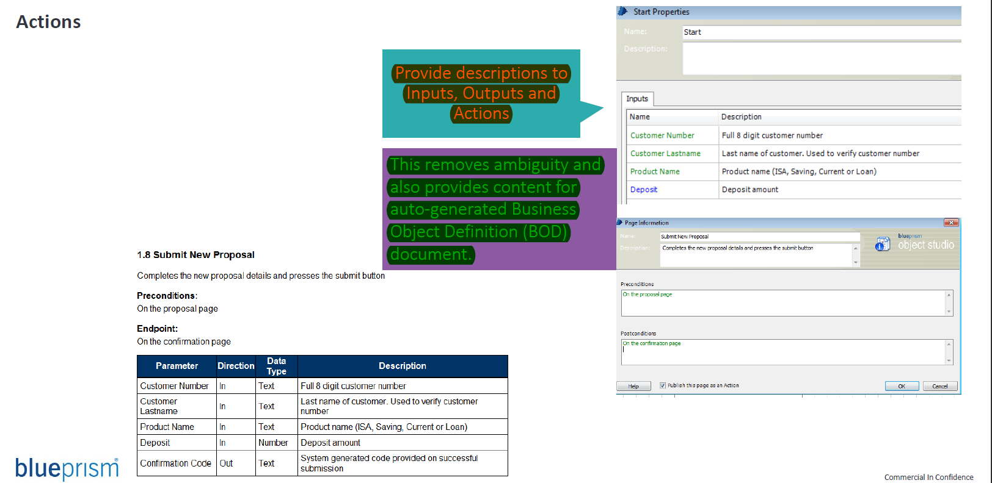

Grouping of data, use of initialise page, environment variables for ‘changing data’

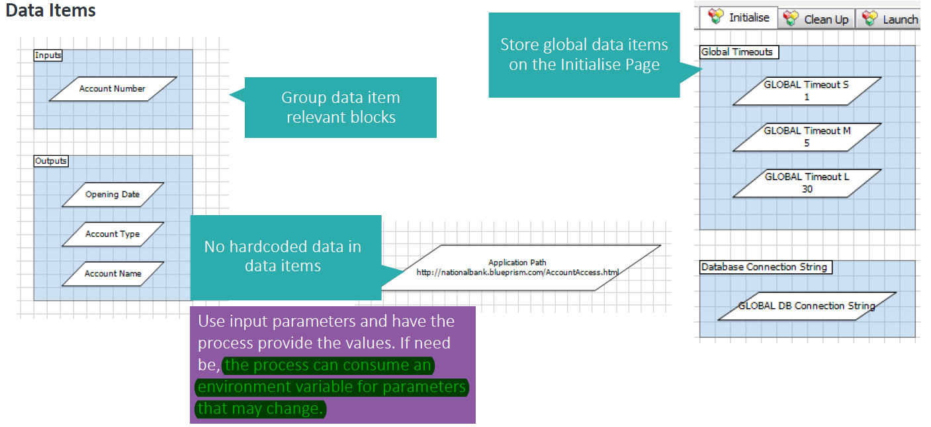

Use add element to add main nodes/add child to add elements inside the main node

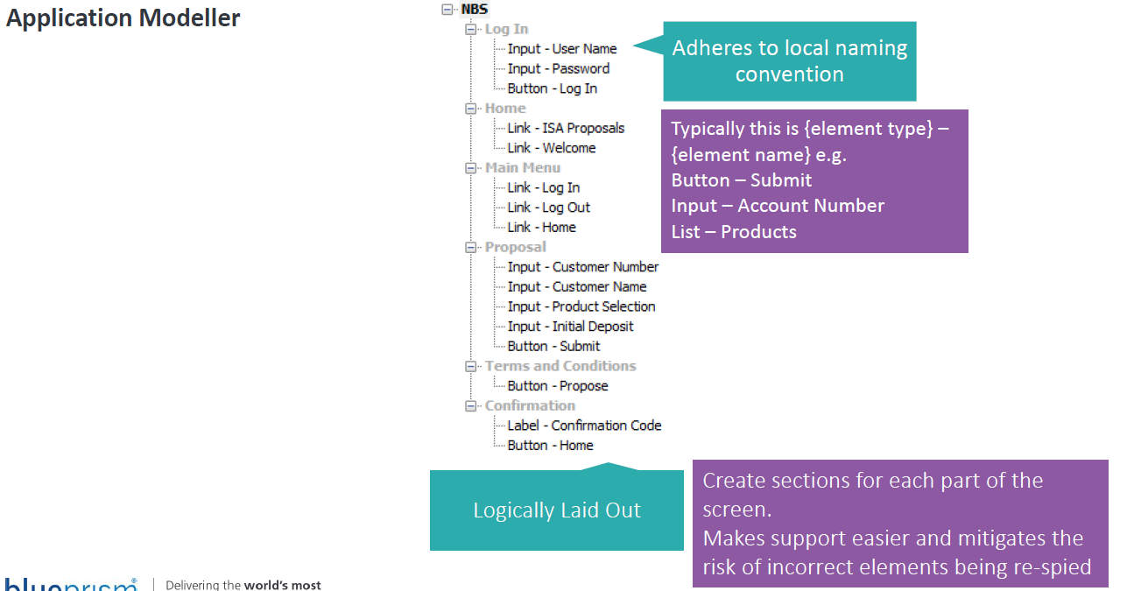

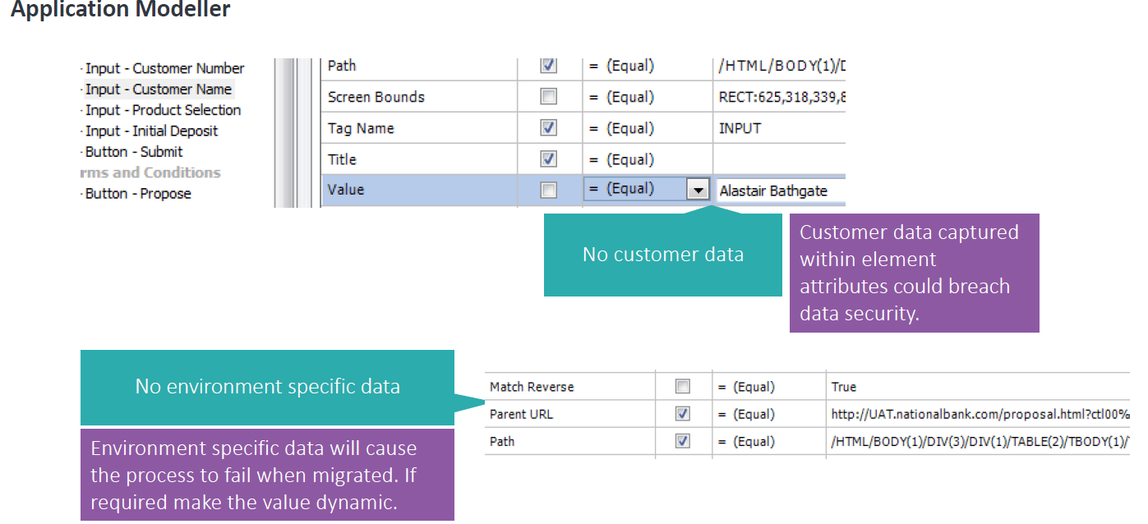

Run Mode options and Exposure of objects

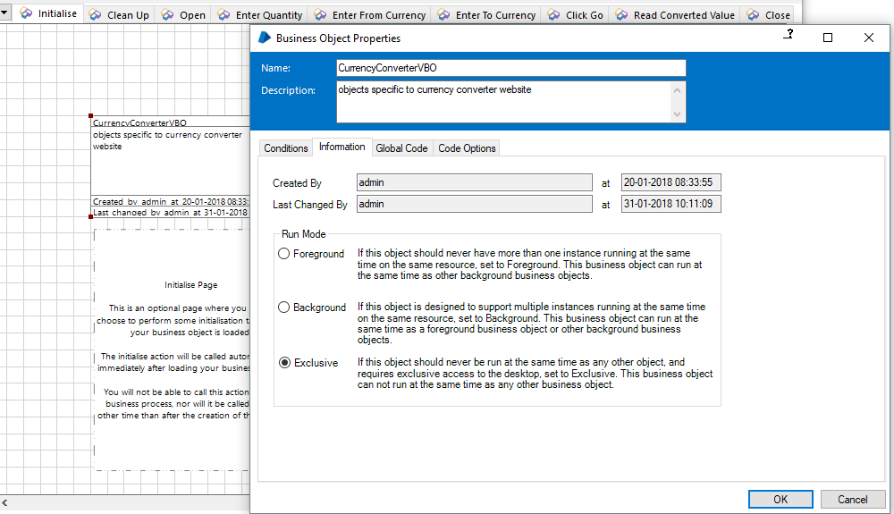

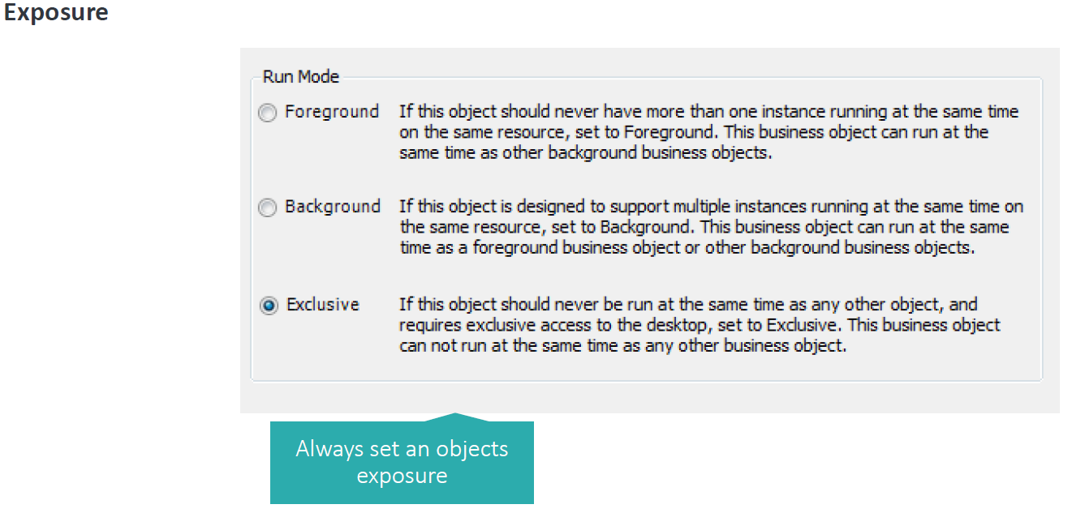

For process, understand how to construct a process. Add additional refactoring logic after covering basic happy paths

* Main page should not be crowded. Only describe a high level flow. Use Start-up, Closedown, Populate Queue, Sub process pages.
* Post this, add Stop logic to main page before working on a new item. (C)
* Post this, add an exception block to main page enclosing the subpages which interacts with application - recover, mark item as exception and resume stages. (R)
* Sub page retry loops – recover, decision(3), resume, tidy. (R)
* Concurrent exceptions – terminate process. (R)

* go through document to understand the building blocks visually

Other Improvements –

* Environment variables.
* Work queue tags – All queue items that are in exception must either be tagged as System Exceptions or Business exceptions.

Other tags to get total number of different case or work types.

* Always use process templates.

You will have to create a new session first

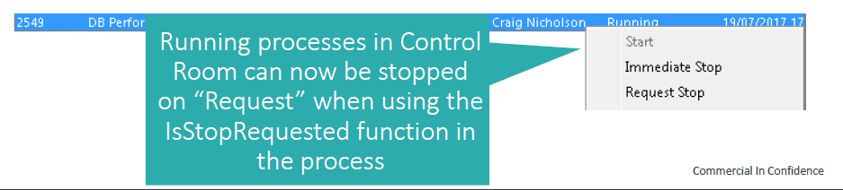

**Creating a session**

In order to start a new session, drag a process onto the required resource, or drag a resource onto the required process.

TIP: To quickly run one process on several resources, select several resources by dragging the mouse and drag the entire selection over a single process.

Pending sessions appear in the list view in the lower half of the window and are coloured orange.

**Starting a session**

To start pending sessions, select all desired sessions (using the control key to select more than one session) and click the Start Selection link, or right-click the selection and choose Start.

**Stopping a session**

To ''immediately'' stop a running session, or a set of sessions, select all desired sessions (using the control key to select more than one session) and click the Stop Selection link, or right-click the selection and choose Immediate Stop.

To request a ''safe'' stop in a running session or set of sessions, select all desired sessions (using the control key to select more than one session), then right-click the selection and choose Request Stop. A flag is set on the session that the running process can check using the IsStopRequested() environment function, allowing it to exit cleanly from its current operations.

